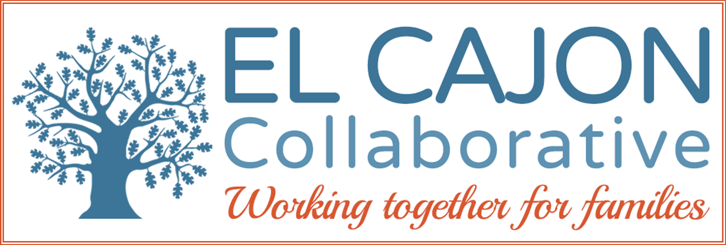

El Cajon Collaborative Council Meeting

September 6, 2017 / 12:30 – 2:00pm
Cajon Valley Union School District Board Room
750 E. Main St., El Cajon, CA 92020
Meeting Purpose:
To engage community members in resource sharing, networking, and action to benefit the children, youth and families of El Cajon

Meeting Agenda

Welcoming Remarks & Introductions (5 minutes)

Newcomers’ Collaborative: (5 minutes)

May Hassan, Co-Chair Newcomers’ Collaborative

III. Homeless Services Work Group: (5 minutes)

Updates on ECC Work Group

IV. Short Presentation: (10 minutes)

Topic: MHS ACTION East

Program: Mental Health Systems
Presenter: Debra Hullaby, CATC-Case Manager

V. Short Presentation: (20 minutes)

Topic: Making Connections- Connections 2020

Program: YMCA Youth & Family Services
Presenter: Freda Hernandez- Support Specialist Coordinator

VI. Presentation: (30 minutes)

Topic: Pathways to Success

Program: PCG
Presenter: Veronica Chariva and Karen Shelton-Jackson, Program Coordinators

VII. Announcements and Sharing (15 minutes)

VIII. Adjournment
Upcoming Meetings:
Newcomers’ Collaborative Meetings- September 12
HHSA-East Region Conference Room 10:30-12:00
Next ECC Meeting- October 3
CVUSD Board Room 750 E. Main St., El Cajon Bring a Sack Lunch.
12:30-2:00 pm
Next Homeless Services Work Group- TBD CVUSD Board Room 9:00 -10:30

2016-2020 Overall Strategic Focus
El Cajon Collaborative

Goals:
- Increase pro-social activities for children and youth:
  - Objective: Increase access to safe & healthy recreational opportunities
  - Objective: Increase opportunities for meaningful youth leadership and civic engagement.

- Increase community involvement in Collaborative partnerships:
  - Objective: Increase community engagement in self-sufficiency opportunities.
  - Objective: Increase community partnerships to support cultural inclusion.
  - Objective: Mobilize residents to proactively participate in community enhancement activities.

- Enhance prevention strategies using the public health model:
  - Objective: Advance opportunities to create safe, healthy and livable neighborhoods (universal)
  - Objective: Improve community health & wellness through resident engagement (secondary)
  - Objective: Increase culturally appropriate healthcare services (targeted)

- Increase advocacy efforts to support policies that:
  - Objective: Ensure safe, fair and affordable housing across the continuum of need;
  - Objective: Promote economic development to adequately ensure self-sufficiency;
  - Objective: Provide educational opportunities leading to career pathways;
  - Objective: Address community environments and norms to foster health.

