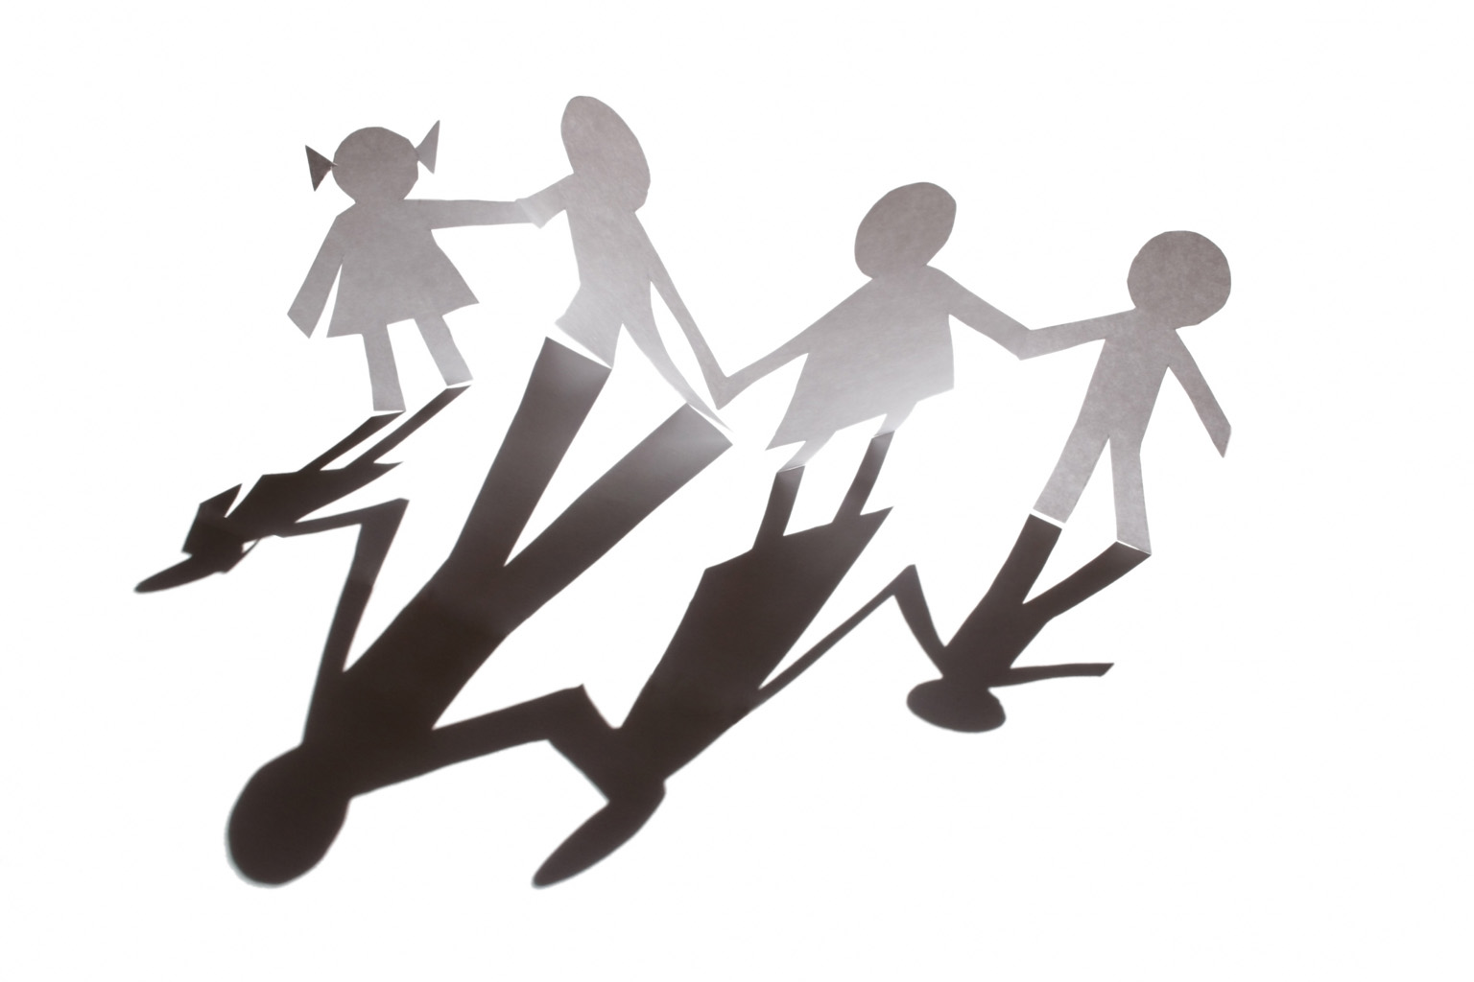El Cajon Collaborative Council Meeting

August 4, 2015 / 12:30 – 2:00pm
Bill Beck Park Planning Meeting/Picnic
El Cajon, CA 92020
Meeting Purpose:
To engage community members in resource sharing, networking, and action to benefit the children, youth and families of El Cajon

Agenda

Welcoming Remarks & Introductions: (5 minutes)

Lunch and Networking (20 minutes)

Small Group Planning (30 minutes)

IV. Group Overview and Strategies

V. Announcements

Next Meeting: Collaborative Council Meeting
Tuesday, September 1, 2015
12:30-2:00pm
Cajon Valley Union School District (Board Room)
750 E. Main St., El Cajon
Bring a sack lunch.

El Cajon Collaborative Strategic Work Priorities
Overall Strategic Focus: Public Safety and Youth

Goals:
- Increase pro-social activities for youth
  - Objective A: Engage community into recreation facilities and activities
  - Objective B: Seek opportunities for mentoring our youth

- Increase community involvement in Collaborative partnerships
- Objective A: Mobilize residents to proactively participate in public safety activities

- Enhance prevention activities for youth using the public health model of universal, secondary and targeted interventions.
  - Objective A: Improve community wellness
  - Objective B: Increase community partnerships to prevent bullying and provide character education.

***Measurable outcomes will be determined for each objective through Core Team.

