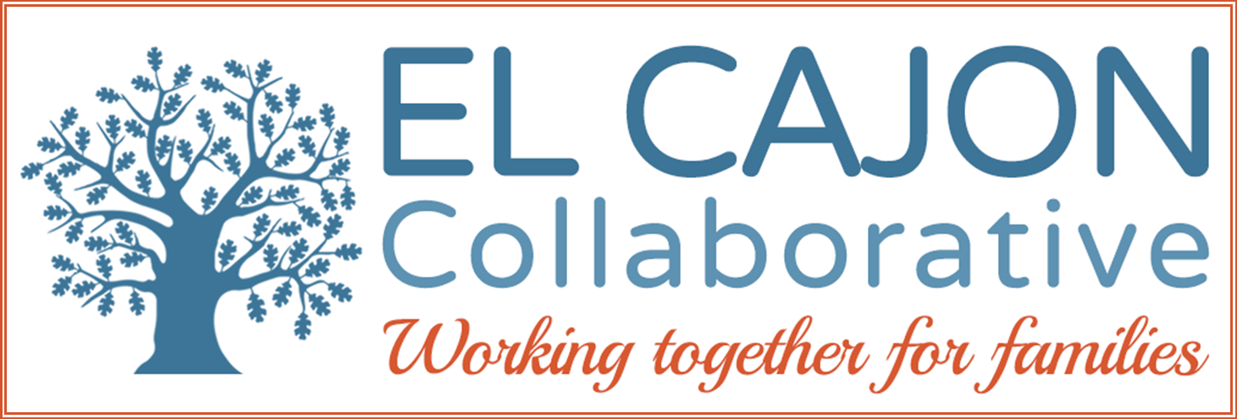

El Cajon Collaborative Council Meeting

February 6, 2018 / 12:30 – 2:00pm
El Cajon Police Department- Community Room
100 Civic Center Way, El Cajon, CA 92020
Meeting Purpose:
To engage community members in resource sharing, networking, and action to benefit the children, youth and families of El Cajon

Meeting Agenda

Making Transportation Accessible for Everyone

Welcoming Remarks & Introductions (5 minutes)

Short Presentation: (5 minutes)

Program: New programs at Crisis House
Presenter: Lori Saldate, MSW Domestic Violence Housing and Assessment Coordinator

II. Homeless Services: (10 minutes)

Topic: Updates on Tony

Topic: Regional Task Force & East County Updates

III. Presentation: (20 minutes)

Topic: Transit District Plan

Program: City of El Cajon
Presenter: Melissa Devine, AICP - Senior Planner, Community Development Dept.

IV. Presentation: (20 minutes)

Topic: Safe Routes to School

Program: Center for Healthier Communities- Rady Children’s Hospital
Presenter: Lakeysha Sowunmi, Program Coordinator

V. Presentation: (20 minutes)
Topic: The Future of Public Transportation
Program: SANDAG Regional Plan 2019
Presenter: Carol Lewis, Collaborative Coordinator

VI. Announcements and Sharing (10 minutes)

VII. Adjournment

2016-2020 Overall Strategic Focus
El Cajon Collaborative

Goals:
- Increase pro-social activities for children and youth:
  - Objective: Increase access to safe & healthy recreational opportunities
  - Objective: Increase opportunities for meaningful youth leadership and civic engagement.

- Increase community involvement in Collaborative partnerships:
  - Objective: Increase community engagement in self-sufficiency opportunities.
  - Objective: Increase community partnerships to support cultural inclusion.
  - Objective: Mobilize residents to proactively participate in community enhancement activities.

- Enhance prevention strategies using the public health model:
  - Objective: Advance opportunities to create safe, healthy and livable neighborhoods (universal)
  - Objective: Improve community health & wellness through resident engagement (secondary)
  - Objective: Increase culturally appropriate healthcare services (targeted)

- Increase advocacy efforts to support policies that:
  - Objective: Ensure safe, fair and affordable housing across the continuum of need;
  - Objective: Promote economic development to adequately ensure self-sufficiency;
  - Objective: Provide educational opportunities leading to career pathways;
  - Objective: Address community environments and norms to foster health.

