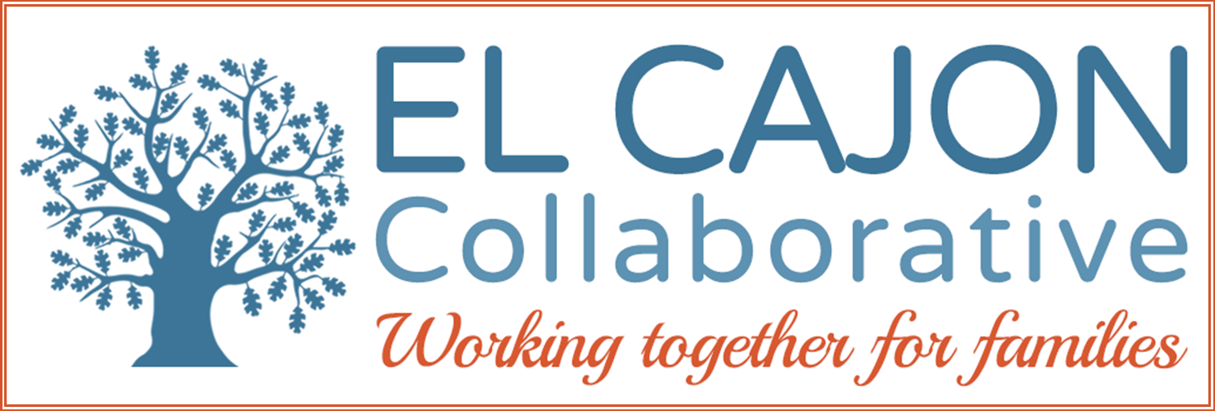

El Cajon Collaborative Council Meeting

December 5, 2017 / 12:30 – 2:00pm
Cajon Valley Union School District Board Room
750 E. Main St., El Cajon, CA 92020
Meeting Purpose:
To engage community members in resource sharing, networking, and action to benefit the children, youth and families of El Cajon

Meeting Agenda

Welcoming Remarks & Introductions:

II. Presentation:

Topic: Homelessness

Program: “Tony, the Movie”
Presenter: Dennis Stein, Filmmaker and South Park Resident
Tony Rodriguez- San Diego native

III. Panel Discussion:

Panelists:

Dennis Stein, Film Creator

Tony Rodriguez

Mary Case, CEO Crisis House

Eric Lund, CEO East County Chamber of Commerce
Facilitator: Carol Lewis, El Cajon Collaborative

IV. Announcements

V. Adjournment

Upcoming Meetings:
Newcomers’ Collaborative Meetings- December 12
HHSA-East Region Conference Room 10:30-12:00
Next ECC Meeting- February 6, 2018 12:30-2:00 p.m. DARK in January
El Cajon Police Dept. Community Room, 100 Civic Center Wy., El Cajon
Bring a Sack Lunch.
Next Homeless Services Work Group- November 7 Little House 9:00 -10:30
131 Avocado Ave., El Cajon

2016-2020 Overall Strategic Focus
El Cajon Collaborative

Goals:
- Increase pro-social activities for children and youth:
  - Objective: Increase access to safe & healthy recreational opportunities
  - Objective: Increase opportunities for meaningful youth leadership and civic engagement.

- Increase community involvement in Collaborative partnerships:
  - Objective: Increase community engagement in self-sufficiency opportunities.
  - Objective: Increase community partnerships to support cultural inclusion.
  - Objective: Mobilize residents to proactively participate in community enhancement activities.

- Enhance prevention strategies using the public health model:
  - Objective: Advance opportunities to create safe, healthy and livable neighborhoods (universal)
  - Objective: Improve community health & wellness through resident engagement (secondary)
  - Objective: Increase culturally appropriate healthcare services (targeted)

- Increase advocacy efforts to support policies that:
  - Objective: Ensure safe, fair and affordable housing across the continuum of need;
  - Objective: Promote economic development to adequately ensure self-sufficiency;
  - Objective: Provide educational opportunities leading to career pathways;
  - Objective: Address community environments and norms to foster health.

