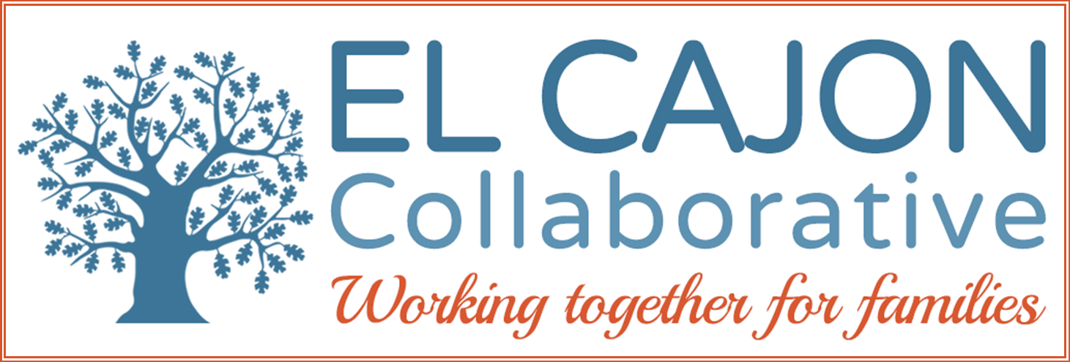

El Cajon Collaborative Council Meeting

April 7, 2020 / 12:30 – 2:00pm
Cajon Valley Union School District
750 E. Main St., El Cajon, CA 92020
Meeting Purpose:
To engage community members in resource sharing, networking, and action to benefit the children, youth and families of El Cajon

Meeting Agenda

A Healthier El Cajon—Addressing Homelessness

Welcoming Remarks, Introductions & Announcements: (10 minutes)

Recap of World of Wellness Resource Fair: Lexington Elementary School (10 minutes)

Presentation: Farm to School Collective: A Project of CHIP and CVUSD (20 minutes)

Addressing Homelessness in El Cajon and East County: (50 minutes)

Panelists:

City of El Cajon, City Manager Graham Mitchell
East Co. Homeless Task Force, Anna Marie Snyder-Piconi
Home Start, Inc., Laura Tancredi-Baese

V. Adjournment

Next Meeting: Tuesday, May 5th 12:30 p.m. CVUSD Board Room
Next Homeless Services Work Group: Tuesday, May 5th 9:00 a.m. CVUSD Board Room
Next Community Health Work Group: Tuesday, April 21st 8:30 a.m. Little House

2020
Persons who have been homeless carry within them a certain philosophy of life which makes them apprehensive about ownership. --- Jerzy Kozinski

2020-2024 Overall Strategic Focus
El Cajon Collaborative

- Increase access to healthy, nutritious food:
- Objective: Assess retail stores and work towards creating healthy markets in El Cajon;
- Objective: Organize nutrition education to youth and adults at community events through CalFresh Healthy Living;
- Objective: Ensure CalFresh application assistance at all community events and education on changes to the program;

- Enhance prevention strategies and increase advocacy efforts for mental wellness and substance abuse prevention:
  - Objective: Promote ACES education to the public and school districts;
  - Objective: Support anti-bullying campaigns and education to families;
  - Objective: Create community partnerships for IEP trainings and advocacy;
  - Objective: Promote drug-free, smoke-free environments;

- Advance opportunities to create safe, healthy and livable neighborhoods.
  - Objective: Ensure safe, fair and affordable housing across the continuum of need;
  - Objective: Increase community engagement in self-sufficiency opportunities;
  - Objective: Increase opportunities for meaningful leadership and civic engagement;
  - Objective: Support community-wide activities for families and individuals that are experiencing homelessness or are at risk;

- Support the Cajon Valley Union School District (CVUSD) for Health and Wellness Activities and Policies.
  - Objective: Serve as the Wellness Council for CVUSD to build awareness of and engagement in school and district-wide health policy development, implementation, review and updates;
  - Objective: Organize and execute a district-wide Wellness Fair with stakeholders to share information with students, staff, families and the community about healthy eating, physical activity, health services and other local health and wellness resources.

